**Access Control: Because Not Everyone Needs the Keys to Everything**

**How to stop treating your network like a free buffet**

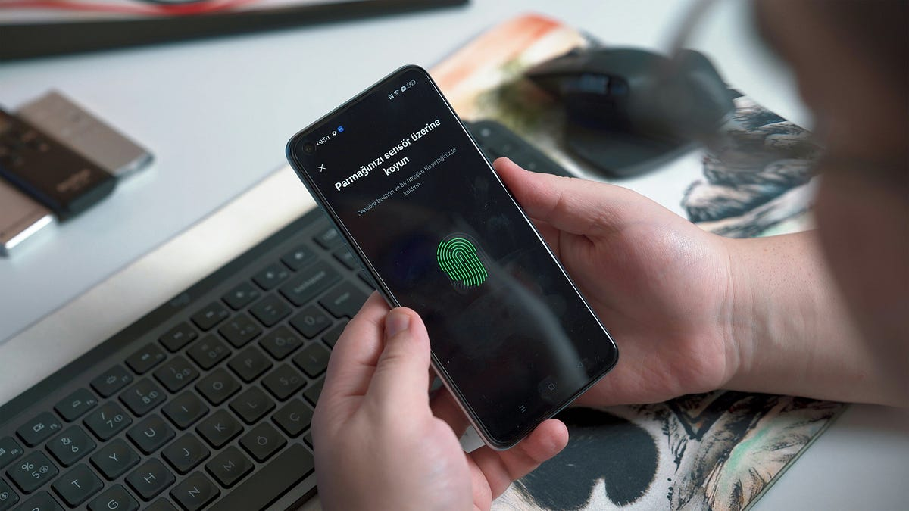Photo by [Onur Binay](https://unsplash.com/@onurbinay?utm_source=medium&utm_medium=referral) on [Unsplash](https://unsplash.com?utm_source=medium&utm_medium=referral)

Let me start this article with quite an uncomfortable (or unsettling) question:

If someone walked into your office right now, sat at a random desk, and started accessing customer data (by chance), would your systems even blink?

If your answer is “hopefully not”, congrats. This is exactly why **Access Controls** are important.

Because let’s make it clear: Not everyone should access everything, not every system should trust everyone. Yet somehow, in the age of cloud and digital revolutions and Bla, Bla, some still consider access control lightly.

**What is Access Control?**

At its core, access control is nothing but about defining who gets to do what, and when.

[image](https://media0.giphy.com/media/v1.Y2lkPTc5MGI3NjExcXhtcWJjcnd3dmw2djhhM281Y2gyYWRuYzNnZW9kbTJxeG0zbzRmcSZlcD12MV9pbnRlcm5hbF9naWZfYnlfaWQmY3Q9Zw/vIvFtVKG0pP7DvK7Bg/giphy.gif) from [GIPHY](https://giphy.com/)

It is the relationship between:

* Subjects (users, processes, systems)
* Objects (files, data, databases, API, etc.)

It ensures that your junior intern doesn’t accidentally delete your production database, and that your finance spreadsheets aren’t floating around in public folders.

**Access Control is Not Just Passwords**

Let us make this stance clear. Access control is not just about logins or passwords. It is a full-fledged security discipline built around the CIA triad. (Don't even know what is the CIA triad? Learn [Here](https://medium.com/zero2root/the-fundamentals-of-infosec-protecting-your-digital-assets-like-a-pro-c62c7d1488e9)). Anyways in simple:

* Confidentiality: Keep stuff secret
* Integrity: Make sure stuff doesn’t get tampered with
* Availability: Let the right people in, when they need it

The only way triad works is if access is managed with precision, not chaos.

And that’s where modern systems come in:

Welcome IAM (Identity and Access Management), the DIGITAL gatekeeper.

[image](https://media2.giphy.com/media/v1.Y2lkPTc5MGI3NjExOTgwa3ZsZDczeG00YnltZW4wN2h2MmVyczloMjk1MjFiaGFnMzk0aCZlcD12MV9pbnRlcm5hbF9naWZfYnlfaWQmY3Q9Zw/nGrPqYRHiLBqfKjLp1/giphy.gif) extracted from [GIPHY](https://giphy.com/)

**The Four Pillars of IAM (Remember AAA+1)**

IAM isn’t just about granting access, it is a structured process with four steps (often remembered as AAA with an extra A)

* **Identification**: “Who are You?”

You create a unique id for a user/system. Think username, employee IDs, API keys.

If this skip is stepped (No, you didn’t read it wrong, it is meant to catch the focus), you have anonymous access, a hacker’s dream.

* **Authentication**: “Prove it”

Now that you have claimed who you are, prove it. This is where passwords, biometrics, tokens, and MFA comes into play.

* **Authorization**: “What Can you Do?”

Even after you prove your identity, that doesn’t mean you get full access. Authorization basically defines what you are allowed to do, read, write, delete, or just awkwardly view.

Your marketing intern (or even an employee) does not need SSH access to production. Not Debatable.

* **Accounting**: “What did you Do?”

This is “who-touched-what-and-when” logs. Think audit trails, logs, and session records.

Because when something breaks or leaks, you want receipts. And no, “vibes” aren’t permissible in an audit.

**Why Access Control Actually Matters**

[image](https://media3.giphy.com/media/v1.Y2lkPTc5MGI3NjExeWRkNm45b256NmVvYWp4Z2FkdjFxMjF3MTNmcG04Nnhmbjk1cWRodCZlcD12MV9pbnRlcm5hbF9naWZfYnlfaWQmY3Q9Zw/kShL0gh7XWoqk/giphy.gif) from [GIPHY](https://giphy.com/)

**Without access control:**

* Your users become liabilities
* Your data becomes dangerously public
* Your systems can’t distinguish friend from foe
* And your post-incident report will start with, “We didn’t think it would happen to us”

**Strong access control:**

* Minimizes insider threat
* Prevents accidental damage
* Makes audit less terrifying
* Supports zero trust architectures (“Never trust, always verify”)

**Bonus: Common Access Control Models**

(Just in case you want to sound smart in a meeting, not really)

[image](https://media0.giphy.com/media/v1.Y2lkPTc5MGI3NjExN254bHc4dXJqaDJmZzUzaDlndTBpejRnYTlldThvYWwybWNod3FseCZlcD12MV9pbnRlcm5hbF9naWZfYnlfaWQmY3Q9Zw/1iu8uG2cjYFZS6wTxv/giphy.gif) from [GIPHY](https://giphy.com/)

* **MAC (Mandatory Access Control):** Military-grade. Admin defines access, users follow orders.
* **DAC (Discretionary Access Control):** Users control their resources. Great for collaboration, horrible for security.
* **RBAC (Role-based Access Control):** Access based on roles, clean, scalable, and enterprise-friendly.
* **ABAC (Attribute-based Access Control):** Access depends on attributes like department, time of day, IP. Fancy, flexible, and sometimes over complicated.

**Conclusion**

If your organization still thinks “one login to rule them all” is a cool approach, it is time to rethink things. Access control isn’t a burden, It is sanity-preserving, risk-reducing essential.

**Previous Posts in the Foundational Series:**

[Mind the Gap: How Gap Analysis Keeps Your Cybersecurity Strategy from Being a Delusion | by DarKVoicE | Zero2Root | Jul, 2025 | Medium](https://medium.com/zero2root/mind-the-gap-how-gap-analysis-keeps-your-cybersecurity-strategy-from-being-a-delusion-689d25a391ec)

**Enjoyed the read?**  
Smash the follow button, drop a comment, and share this with someone who still thinks “password” is a good password.

If you enjoyed the reading, kindly subscribe to my page: [Here](https://medium.com/@Ethical_DarKVoicE/subscribe)